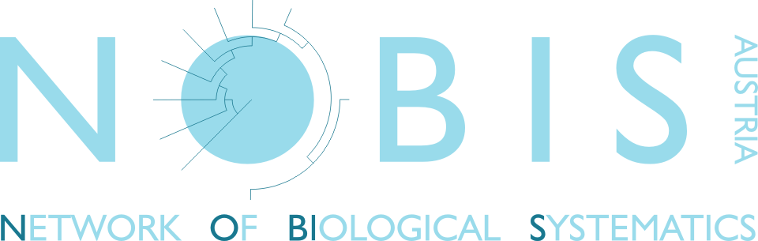

NOBIS-Stipendium 2018
Project title (200 char.):
Name of applicant:
Title:
male female
Address:
E-mail:

Project description incl. methodology & work plan (2700 char. incl. spaces):

Funding source for project (other than NOBIS grant):

Employment status of the applicant: none/ temporary/ permanent
Employer (Institute):
Contact of reference person (optional):

Name your five best publications, if publications are already available
(published papers only, no abstracts):

Notice: pdfs of these publications must be attached to the submission

